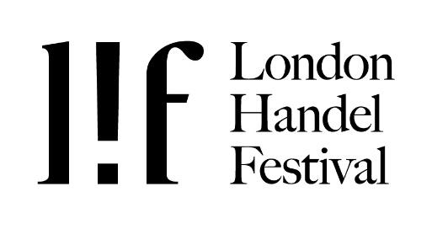

FURTHER DETAILS

YOUR DETAILS
Please complete the first stage of the registration online, entering your details and making your payment of the £40 fee. Then, please complete this form with further details and send with supporting documentation as listed below by e-mail to competition@londonhandelfestival.org.uk. Please note that we prefer to receive type-written applications. If you are writing by hand, please use block capitals throughout and use black ink.

Last name __________________________ First name(s) __________________________________

Address ___________________________________________________________________________

__________________________________________________________ Postcode ______________

Tel No ____________________________________ Mobile No _____________________________

Email ______________________________________________________

Nationality ________________________________ Voice ________________________________

Date* & place of birth ________________________ ___________________________________

* please note that all applicants should be aged between 23 and 34 years old as of 1 February 2019

I have entered my details online and paid my registration fee (please tick)

APPLICATION DOCUMENTS
There are a number of documents you must include with your application. Please check that you have included everything required before you submit your application. All relevant documents should be e-mailed with this document to competition@londonhandelfestival.org.uk

1 Links or copies of your preliminary recording / video. A good quality sound recording or video performing a short aria by Handel. Ideally to include the recit for that aria. The aria should be at least 3 minutes long (including any da capo). The recording can be accompanied by a keyboard instrument.
2 Photocopy of Birth Certificate or Passport, scanned and sent by email
3 Curriculum Vitae (summary of singing career to date), no more than 2 pages with a focus on your musical achievements only & references from 2 credible referees (see section below)
4 Jpeg colour photograph (high resolution) and short concert biography of 200 words

If you have any questions, please e-mail competition@londonhandelfestival.org.uk.

FIRST ROUND

I am available on 9 February 2022 (please tick)
I am available on 10 February 2022 (please tick)
I am available on 11 February 2022 (please tick)

It helps us if you are available for as many days as possible during the First Round. If you already know that you are busy on certain days, please let us know as soon as possible, and we will do our best to accommodate you. Please write comments below about your availability if necessary.

Comments:

REFEREES

1. Name _________________________________________________________________________

Position ________________________________________________________________________

Tel No ____________________________ Email _____________________________________

2. Name _________________________________________________________________________

Position ________________________________________________________________________

Tel No ____________________________ Email ______________________________________

Please include your references below - a couple of sentences or short paragraph will suffice, and please indicate the name of your referee next to each reference. We are happy for the referees to send their letter of recommendation direct by e-mail to competition@londonhandelfestival.org.uk, but they should state clearly your name and voice type in their subject heading.

Add references here:

REPERTOIRE
Please keep a copy of this page for yourself

Name _________________________________________________________________

Voice _____________________________________

If you have been allocated an accompanist, you must bring copies of music for them in the first two rounds - we cannot provide copying facilities. Please list the work from which the piece is taken, HWV number and title. Programme times must include settling, tuning, rests between pieces etc.

PRELIMINARY ROUND
Deadline 20 December 2022. A good quality sound recording or video performing a short aria by Handel. Ideally to include the recit for that aria. The aria should be at least 3 minutes long (including any da capo). The recording can be accompanied by a keyboard instrument.

HWV no Title of piece, work Duration of piece
_________________ ___________________________________________ _____________

FIRST ROUND
9 - 11 February 2022 – Craxton Studios, 14 Kidderpore Avenue, London, NW3 7SU
Maximum time of 10 minutes. A short recitative and aria; plus a second aria. One (or both as long as it doesn’t exceed the time) must include da capo - all music by Handel. Accompaniment is provided by harpsichord at A=415. All recordings submitted must be with harpsichord or baroque ensemble.

HWV no Title of piece, work Duration of piece
_________________ ___________________________________________ _____________

_________________ ___________________________________________ _____________

Please note that it is not possible to repeat repertoire from one stage to the next in the competition.

Check-list
Please check you have included all documents as listed on p1. Thank you for applying, and good luck!

